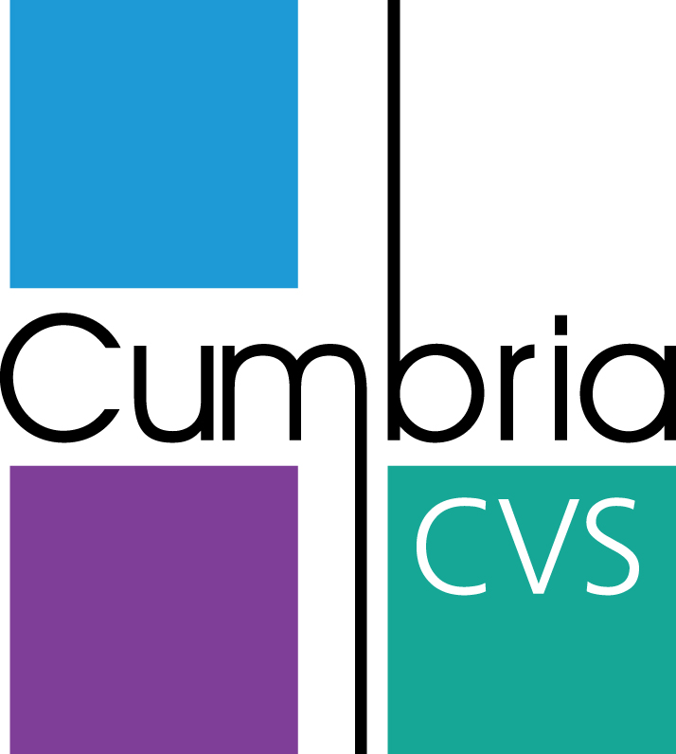
Volunteer Role Description

Role Title: | Graphic Design Volunteer - Volunteering opportunities
Where is the role based: | This is a virtual home based volunteering role with virtual meetings as and when needed.
Role Purpose: | To support the County Volunteer Support Officer to develop and raise the profile of volunteering in Cumbria. The role is to showcase the range of volunteering opportunities available by creating graphic design images for social media promotion and other forms of publicity.
Frequency: | 2 hours a week though this is a flexible role which can be created around the volunteer so can be from 1 hour to a day a week.
Actual Hours: | This role is flexible around the volunteer so can be done during the day, evenings or weekends.
Key tasks: | - Help develop graphic design images of volunteering opportunities in Cumbria which will then be shared on social media. These could be either small images or posters depending on the volunteer recruitment campaign and best method.  - To support the digital delivery and promotion of Volunteering Opportunities and Volunteering Online events and activities.
Skills required: | To have experience and knowledge of:  - Graphic design for social media posts and posters in general  - IT skills when using appropriate graphic design software  - Creative and innovative  - Ability to work independently and use own initiative  - Good communication skills  - Understanding the importance of brand colours and professional images for social media
What’s in it for the individual  (list at least 4 benefits) | - Be a part of a welcoming, friendly and enthusiastic team  - Utilise and develop your graphic design and digital skills and knowledge  - Make a difference to the communities in Cumbria supporting local charities and community groups to recruit new volunteers.  - Empowering and encouraging more people in Cumbria to become volunteers during Covid-19 and beyond  - Improve your confidence and self-esteem  - Sharing your skills with Cumbria CVS and the Third Sector in Cumbria  - Understanding more about the vibrant community sector in Cumbria  - Be a part of Micro-Volunteering  The open development brief will enable you to be creative and innovative and bring your skills and ideas to make an important contribution to the development and delivery of new volunteering promotion to benefit volunteers and organisations in Cumbria.
Equipment required | Access to the internet and use of own computer/ laptop.
Name and contact details of Volunteer Support | Judith Smale, County Volunteer Support Officer, Cumbria CVS  Email: judiths@cumbriacvs.org.uk  Telephone: 01768 800350

